

Tribhuvan University
Faculty of Humanities and Social Sciences

“Bus Ticket Booking and Management System”

A PROJECT REPORT

Submitted to
Department of Computer Application
G.P. Koirala Memorial College
Sifal, Kathmandu

In partial fulfillment of the requirements for the Bachelor’s in Computer Application

Submitted by
Jashan Siwakoti
6-2-703-7-2020
Siddhartha Khadka
6-2-703-16-2020

Abstract
In response to the increasing need for digitized and efficient public transportation services, this project presents the development of a Bus Ticket Booking and Management System—a web-based platform designed to streamline ticketing, scheduling, and bus operations across Nepalese transportation providers. The system offers a unified interface for passengers, bus operators, and administrators to manage their respective tasks efficiently. It eliminates the need for manual bookings and reduces operational inefficiencies by automating the entire process from seat reservation to route management.
It is generally used for Online ticket booking with real-time seat availability, E-ticket generation with QR code support, ser roles: Admin, Operator, Passenger with personalized dashboards Real-time notifications and travel reminders with the
Through this platform, GPKMC campus seeks to improve academic integrity, enhance collaboration, and minimize manual workload, thereby fostering a smarter and more connected educational environment.
the system is designed to be scalable, secure, and user-friendly—ideal for bus companies and travel agencies seeking an affordable digital transformation solution.

Keywords: LMS, eCampus, MERN Stack, Academic Management, Attendance, Assignments, Plagiarism Detection, Role-Based Access, Nepal, Google OAuth

List of abbreviations
AI | Artificial Intelligence
API | Application Programming Interface
CDN | Content Delivery Network
CRUD | Create, Read, Update, Delete
CSP | Constraint Satisfaction Problem
CSS | Cascading Style Sheets
DB | Database
GPKMC | Girija Prasad Koirala Memorial College
HTML | HyperText Markup Language
IDE | Integrated Development Environment
JS | JavaScript
JSON | JavaScript Object Notation
JWT | JSON Web Token
LMS | Learning Management System
NLP | Natural Language Processing
OAuth | Open Authorization
QA | Quality Assurance
REST | Representational State Transfer
SEO | Search Engine Optimization
SMTP | Simple Mail Transfer Protocol
TU | Tribhuvan University
UI | User Interface
UI/UX | User Interface / User Experience
UX | User Experience

List of Figures
Figure 1: Gantt Chart of Learning Management System 8
Figure 2: Agile Software development 9
Figure 3: System Flowchart of Bus Ticket Booking and Management System 10

Contents
Abstract ii
List of abbreviations iii
List of Figures iv
1. Introduction 1
2. Problem Statement 1
3. Objective 2
4. Scope 2
5.1 Development Methodology 3
6: Background study 4
6.1 Background Study 4
5.1.2 Literature Review 5
5.1.3 Requirement Collection 6
5.2 Feasibility Study 7
5.2.4. Schedule Feasibility 8
5.3 High Level Design of System 8
5.3.1 Methodology of Proposed System 8
5.3.2 System Flowchart 9
6. Expected Outcomes 11
Reference 1

1. Introduction
Online bus ticket booking has revolutionized the way people travel by bus, offering convenience, flexibility, and efficiency. Instead of waiting in long queues at bus stations or relying on third-party agents, travelers can now book their bus tickets from the comfort of their homes or on the go, using their computers or mobile devices. Online bus ticket booking platforms provide a user-friendly interface where travelers can search for available bus routes, select their preferred departure and arrival locations, choose travel dates and times, and compare ticket prices and seat availability across different bus operators. Online bus ticket booking platforms typically offer a wide range of bus routes, covering various destinations within a region or country, allowing travelers to easily find routes that suit their needs. Travelers can check real-time availability of seats on different buses, allowing them to secure their preferred seats and travel times in advance. Online bus ticket booking platforms offer flexibility in terms of payment options, allowing travelers to pay for their tickets using credit/debit cards, net banking, mobile wallets, or other digital payment methods. Many online booking platforms allow travelers to choose their preferred seats on the bus, giving them control over their seating preferences and ensuring a comfortable journey.
Online bus ticket booking platforms typically have clear cancellation and refund policies, allowing travelers to cancel their bookings and receive refunds (if applicable) according to specified terms and conditions. Travelers can access customer support services through various channels, such as phone, email, or live chat, to seek assistance with booking inquiries, changes, or issues
.

2. Problem Statement
In today's fast-paced world, the demand for reliable and efficient public transportation
services are growing rapidly. However, many bus operators and travel agencies still rely on manual or partially digitized systems to handle ticket booking, passenger management, and scheduling. These traditional methods are often inefficient, leading to issues such as human error, long queues, mismanagement of schedules, overbooking, and poor communication between operators and passengers.

Furthermore, passengers frequently face challenges accessing up-to-date information, booking or canceling tickets remotely, and receiving timely notifications. Bus operators, on the other hand, struggle with managing seat availability, maintaining accurate passenger records, and optimizing route schedules. The lack of a unified, real-time digital platform results in operational delays, reduced customer satisfaction, and increased administrative burden.

3. Objective
The main Objective of the system will lead to increase in the ticket booking efficiency of
the project staff and member of ticket booking Agency with little throughout. This system
is made as user friendly as possible so that anyone can use it with little knowledge of
system computers, the ticket booking project will reduce the ticket booking tedious job of
system paperwork by keeping all the project details of bus ticket booking, cancelling
tickets are stored in the form database computer’s hard disk. Up-to-date information of
the system Performance status and other enquires. The objectives are:

1. To provide a convenient and easy way for customers to book bus tickets.
2. To Offer a wide range of bus tickets to choose from.
3. To offer 24/7 customer service.
4. Help business to increase sales and improve customer satisfaction.
5. Use secure payment gateway to protect customer data.

4. Scope
The staff will access the system by logging in via the staff portal where they can compare
bus performance and monitor other related business performance issues. The system is a
web-based application. The users will gain access to the available buses per certain routes
and available seats by logging in through the customer.

5.1 Development Methodology
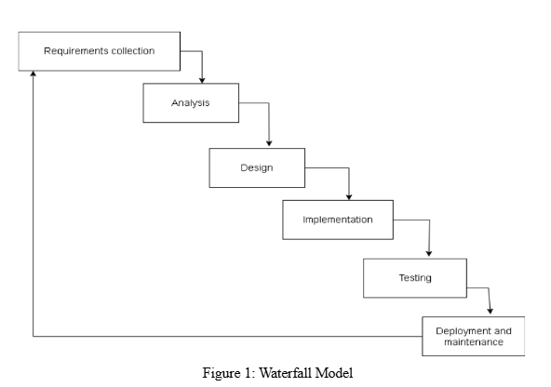
In this model, the life cycle is divided into phases where one phase can be started only after the completion of the previous phase. We chose the waterfall model is suitable for small types of projects and it is simple to understand and use.
1. Sequential development: Waterfall methodology follows a linear and sequential
approach. Each phase of the development process, such as requirements, design,
implementation, testing, deployment, and maintenance, is completed before moving on to the next.
2. Rigidity in Requirements: In Waterfall, the project begins with a thorough
gathering of requirements, which are then documented and fixed. Changes to
requirements are discouraged once the project is underway, making it less
adaptable to evolving market needs.
3. Limited Collaboration: Waterfall typically involves less collaboration. Each phase
has its dedicated team, and communication primarily occurs through formal
documentation rather than daily interactions.

4. Limited User Involvement: User involvement is typically concentrated at the beginning and end of the Waterfall process. Users provide input during the requirements phase, and feedback is collected after the system is fully developed
and tested.
5. Limited Iterations and Improvement: Waterfall is characterized by its lack of
iteration. Once a phase is completed, it is considered final. Continuous
improvement happens mainly during the maintenance phase, and any changes may
require revisiting earlier stages of development.
Requirement Analysis
In this phase, all the possible requirements of the system to be developed are captured
and documented.
- System Design
In this phase, the requirement specifications are studied and the system is
designed. It helps in specifying hardware and system requirements.
- Implementation
With inputs from the system design, the system is developed into small
programs called units, which are integrated into the next phase.
- Testing
All the units developed are tested for any errors and faults and then integrated into a system.
- Deployment
After all the testing is done, the product is deployed into the market.
- Maintenance
After deployment, there may arise issues in the system. To fix this, maintenance
is done to bring changes to the product.

6: Background study

6.1 Background Study
The current system the organization is using is completely manual. Records are stored in
registers and human effort dominate in managing these records increasing cost eventually. Not only these records are reliant but security is poor. Even an unauthorized person could have a peek at these records without managers noticing it. Also, in case of disasters, records could go missing or destroyed which questions the security and safety of records. Security issues and manual human effort remain in the current system which we would try to minimize in our system.

The modules of the system were customer registration, customer booking,
customer checking the seats available or not and so on which we would eventually follow
for system development. Although the system has a disadvantage in many aspects the core concept is good enough. We would be using the E-R data model to define our entities and attributes and prepare database schema according to them. Also, we would be defining how data interacts with the process involved with the DFD diagram.

Abstraction refers to hiding details and showing functionalities. We followed three schema diagrams for abstraction of all levels that would be “physical level abstraction “which describes how data are stored on the system. “Logical level abstraction” which describes data stored in a database.” View level abstraction” describes only part of the database and hides information from the user i.e. user just has to interact with the help of GUI not necessary to know the internal process of how it’s done.

Following the concept of abstraction, there’s the involvement of data independence, which means the capacity to change database schema without affecting the application program.

5.1.2 Literature Review
Mobile Ticketing (M-Ticketing): Mobile ticketing (m-ticketing) can be broadly defined as ordering, purchasing, delivery, and usage of a product or service using mobile technology such as Wireless
Application Protocol (WAP) (Sawyer, Simons, & David, 2004). The mobile ticketing industry is a relatively recent and up-and-coming portion of the fast-growing e-commerce industry. According to some estimates, approximately 400 million mobile subscribers global networking system will use their mobile phones for ticketing by 2013, with total gross mobile ticketing transactions reaching $92 billion by 2013 (Eicher et al., 2012).
Mobile ticketing predictions have been the research domain for several years. M-ticketing permits a customer to purchase a valid and legitimate ticket through a mobile phone application. The value-added services provided by the application allow users of the mobile ticket to store digital tickets on the phone. By doing so, the consumer is less likely to lose his ticket, it is eco-friendly, durable, cost-effective, and paperless. Generally, the mobile ticketing process can be defined in the following steps:
•Registration: Online ticketing requires a company to register with all the business and service information.
•Provisioning: Allow mobile phone applications to interact with customers, allowing the purchase to take place.
•Validation: Validating and legitimate the ticket via an electronic validation system between the company and the customer.
•Ticket check: Controller to verify and accept the sales and display of the mobile ticket as a valid ticket for the passenger, according to the terms displayed on the ticket. [1]

Online Bus Ticket Reservation System: Online Bus Ticket Reservation System is a web-based application that allows visitors to check bus ticket availability, buy bus tickets, and pay cash. By using this application, the company can provide reservation services and information to their customers without the limitation of office hours or manpower. [2]

5.1.3 Requirement Collection
Requirement analysis is the initial task to be performed while developing the system. It was
performed to identify the requirements needed for the system.
- Functional Requirements

Login: The user can book seats and view the schedule of buses.
•Admin: Admin can manage buses and manage the reservation system.
•Booking: User can book tickets as per their requirements.
•Payment: The user can pay through the Internet
Login: The user can book seats and view the schedule of buses.
•Admin: Admin can manage buses and manage the reservation system.
•Booking: User can book tickets as per their requirements.
•Payment: The user can pay through the Internet
Login: The user can book seats and view the schedule of buses.
•Admin: Admin can manage buses and manage the reservation system.
•Booking: User can book tickets as per their requirements.
•Payment: The user can pay through the Internet
- Login: The user can book seats and view the schedule of buses
- Admin: Admin can manage buses and manage the reservation system.
- Booking: User can book tickets as per their requirements.
- Payment: The user can pay through the Internet.

- Non-functional requirements
- Performance: It supports and handles multiple users at a time.
- Reliability: It avoids data inconsistency.
- Availability: It will be deployed on a public server making it accessible to everyone on the internet.
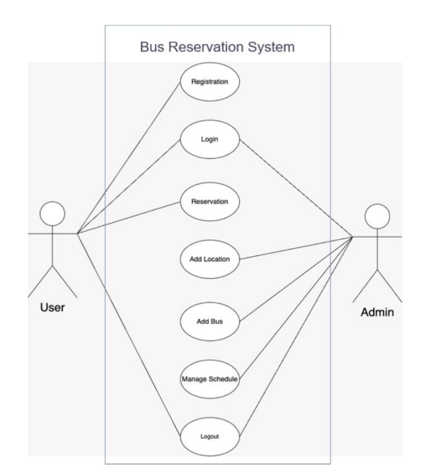

Figure2: Usercase Diagram of Bus Ticket Booking and Management System

5.2 Feasibility Study

The study is conducted to determine whether the proposed system serves its purpose or
not. It also checks workability, ability to meet user’s needs, and effective use of resources.

Economic Feasibility:
The cost of the proposed system will not exceed the cost involved system that is being
used at present. Maintenance of this system costs is low. Hence the system will be
economically feasible

Technical Feasibility:
HTML, CSS, and JS are used for the system’s development and are sufficient to build
as per requirements. It requires a database to store information about users including
their personal information.

Operational Feasibility:
Users can use the system without little or no knowledge because the simple design
and UI make the system operationally feasible

5.2.4. Schedule Feasibility
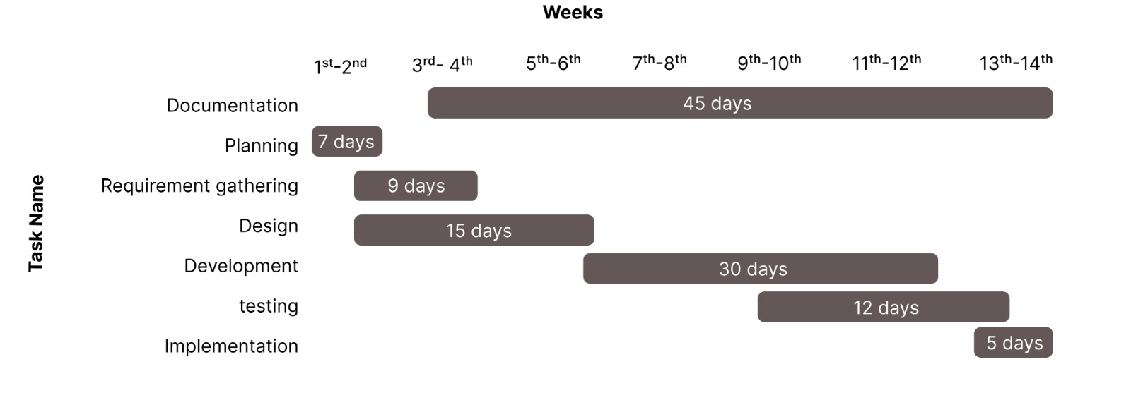

Figure 1: Gantt Chart of Learning Management System
A Gantt Chart is a widely used tool in project management for visualizing project schedules. It displays activities or tasks along a timeline, making it easy to understand the sequence and duration of each task. On the left side of the chart, a list of project activities is presented. Across the top, a time scale (such as days, weeks, or months) is shown. Each activity is represented by a horizontal bar. The position of the bar indicates the start date, while its length reflects the duration of the task, ending at the expected completion date.

5.3 High Level Design of System

5.3.1 Methodology of Proposed System
For the development of the LMS platform, the Agile Methodology will be adopted as the primary software development approach. This methodology is ideal for the project due to its iterative and flexible nature, emphasizing collaboration, continuous feedback, and incremental improvements. The main objective of using Agile is to ensure that the platform adapts effectively to user needs and feedback, enabling the rapid rollout of new features and enhancements.
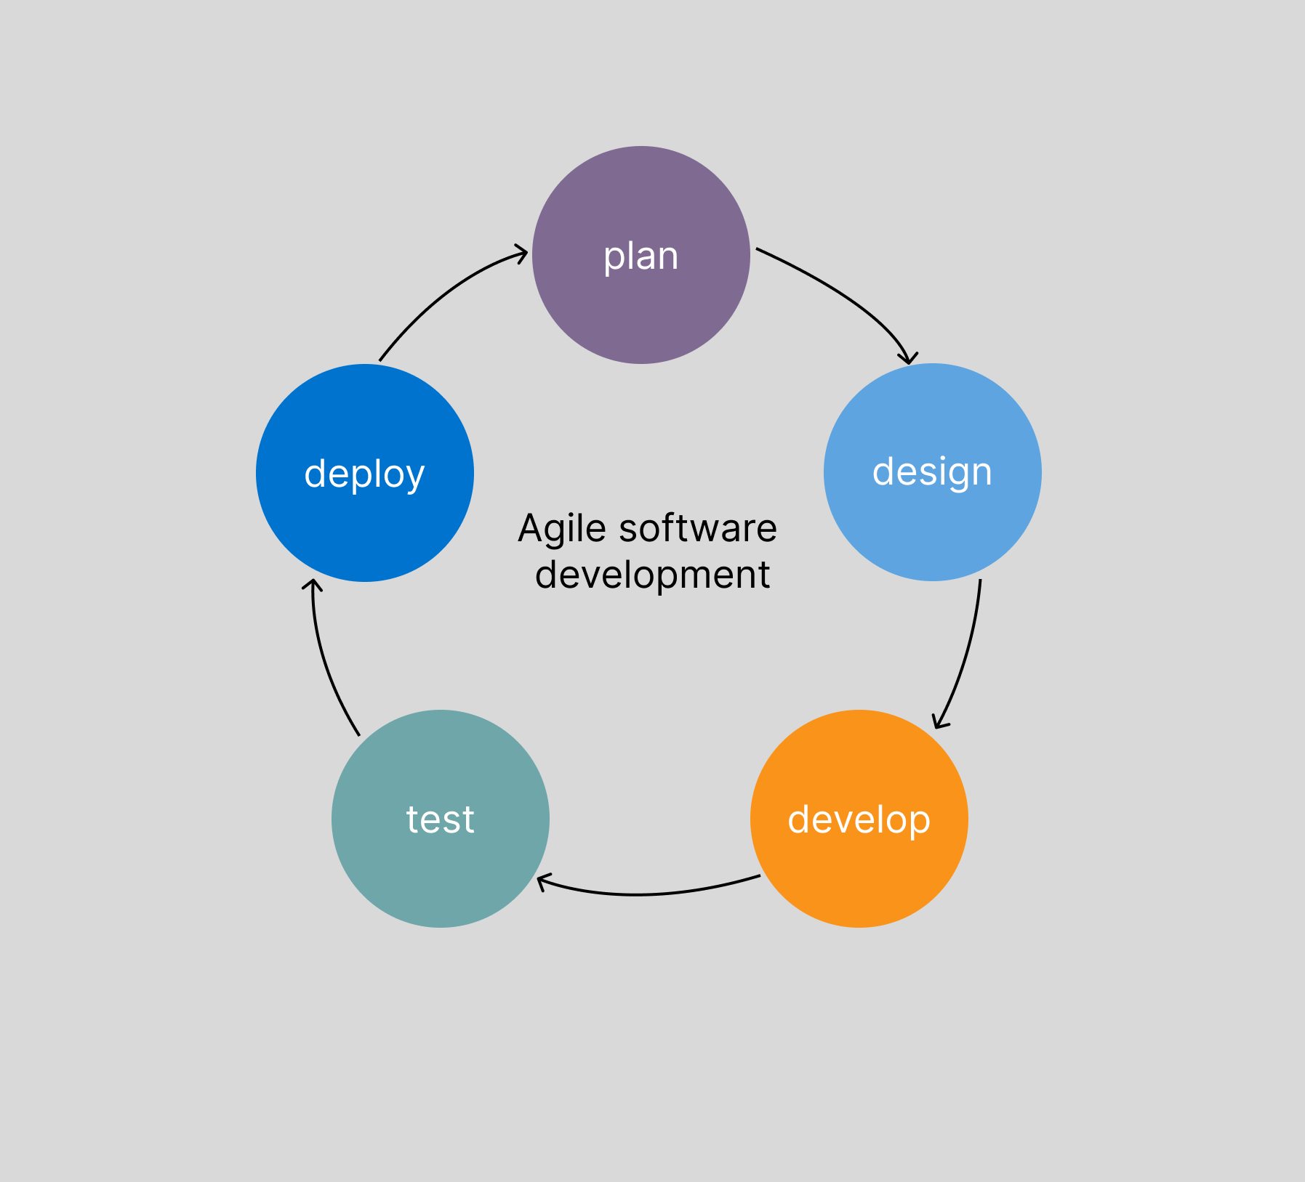
Figure 2: Agile Software development

5.3.2 System Flowchart
In the LMS platform, users visit the website, and they are already registered, they can log in with their credentials to access the system based on their roles such as teacher can access teacher dashboard while admin can access admin dashboard and student can access their own dashboard and each user can access all features based on their roles.

Figure 3: System Flowchart of Bus Ticket Booking and Management System
The Bus Ticket Booking and Management System is a web-based platform designed to digitize and streamline the entire process of booking, managing, and monitoring bus transportation services. The system begins with a secure login portal that directs users to role-specific dashboards—Admin, Operator (Bus Staff), and Passenger.
- Admins have full access to manage routes, schedules, buses, bookings, users, and generate analytical reports. They can also add new destinations, assign buses, and monitor system activity in real-time.
- Operators can view and update trip details, check booking status, mark attendance of passengers, and handle delays or cancellations.
- Passengers can register/login, search for buses by destination and date, book or cancel tickets, choose seats, view booking history, and download e-tickets.
Each dashboard is designed to provide a user-friendly interface with seamless access to needed functionalities, reducing manual errors, long queues, and improving overall service efficiency.

5.3.3 Description of Algorithms Used
- Seat Availability Check:
Real-Time Slot Management + Queue Handling
Ensures that seats are dynamically updated as users view and book them. It handles simultaneous requests using transaction-safe operations to prevent double-booking.

- Route Optimization:
Dijkstra’s Algorithm
Used to determine the most efficient path between multiple stops or cities, ensuring optimal fuel usage and time-saving route planning.

- Fare Calculation:
Distance-Based Dynamic Pricing
Calculates fare based on distance, seat type (AC/Non-AC), and time (peak or off-peak hours). A weighted formula is applied to generate fair and scalable pricing.

- Booking Confirmation & Ticket Generation:
Unique ID Generation + QR Code Encoding
Each confirmed booking generates a unique ticket ID and a QR code, which can be scanned by operators for verification and check-in.

- Passenger Behavior Analysis:
Pandas + Matplotlib (Python)
Analyzes historical booking data to understand peak times, frequent destinations, and popular routes. This helps improve bus allocation and marketing strategies.

- Notification & Reminder System:
Event Scheduling with CRON + SMTP/Push Notifications Automatically sends SMS/email reminders for upcoming trips, cancellations, and promotional offers, improving passenger engagement and reducing no-shows.

- Smart Search System:
Elasticsearch
Allows passengers to quickly search for available routes, buses, and seats using
keywords, with typo-tolerance and real-time filtering.

- Fraud Detection in Booking:
Anomaly Detection with Logistic Regression
Detects suspicious booking patterns such as bulk bookings, repeated cancellations,
or misuse of offers to ensure fair use of the platform.

- User Feedback & Rating System:
Sentiment Analysis using Naive Bayes Classifier
Processes user reviews and classifies them as positive, negative, or neutral, helping the admin take timely actions to improve service quality.

6. Expected Outcomes
- User can reserve bus seats and view schedules
- Provides a real bus schedule so users can be prepared for the bus in time.
- Stores information in the database hence is secure.

Reference
1. Asad, A.A., Ayad, M.J. and Hayder, N.K. (2012). Design and Developing Online Iraqi
Bus Reservation System Using Unified Modelling Language. International Journal of
Scientific knowledge Available at:
http://www.ijsk.org/uploads/3/1/1/7/3117743/v3i103_information_technology.pdf
Accessed 8th May 2022 2. Gayathry, S. Online Bus Reservation System.

2. NwakanmaIfeanyiCosmas, Etus C, Ajere I.U. &AgomuoUchechukwuGodswil,Vol. 1
No.2, 2015,https://www.researchgate.net/profile/Chukwuemeka-
Etus/publication/326468848_Online_Bus_Ticket_Reservation_System/links/5b4fc54b45
851507a7ad6299/Online-Bus-Ticket-Reservation-System.pdf

3. SAWYER, R.H., GOLDING, C. (2012). What is ticket booking? CRC press, (2nd
Edition).

